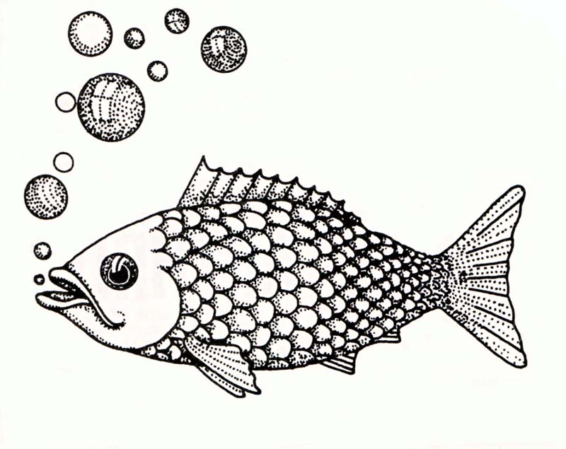

We made it to Lake Mille Lacs! Did you know:
Lake Mille Lacs is over 200 square miles-18 miles long and almost 15 miles wide, Mille Lacs has a maximum depth of only 45 feet. Most of the lake is under 20 feet deep!

We’ve driven 85 miles so far! Did you know that Reese’s candy is 85 years old!!

